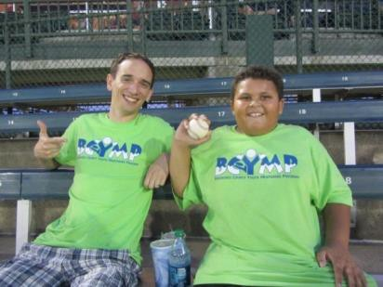

Mentee Application Form

The Brookings County Youth Mentoring Program (BCYMP) …

- Promotes one-on-one mentoring efforts to youth in grades K-12.
- Was incorporated in 2001 to ensure all youth have the guidance and support of a caring, stable adult.

- Is an excellent, proven-effective opportunity to provide a positive and rewarding experience for youth in Brookings County.

- Trains mentors, provides background checks, and matches them with mentees who have similar interests.

- Works closely with school counselors to match mentors and mentees and to facilitate the initial meetings between new mentor/mentee pairs.

- Expects mentors spend at least one hour per week with their mentee doing activities like enjoying shared hobbies, exercising, helping with homework or chores, attending sporting events, movies, and may more.

- Plans free group activities for all mentors and mentees—for example, holiday parties, SDSU ball games, bowling, visits to zoos, museums, and other family fun events.

- Provides regular in-service opportunities for mentors and is always available if they have questions about mentoring.

Do you know a child who could benefit from having a

BCYMP Mentor?
If you would like a mentor for your child or guardian, please complete the application form on the back of this sheet and return it to the BCYMP office or the child’s school. We will add the child to a “potential mentee” list, and match him or her with a mentor as soon as possible. Please be patient with the process. It takes careful screening and recruiting to find mentors in the community and at SDSU, so it may take a while to fill all requests.
Thank you.

Last Updated June 7, 2017

Mentee Application Form

Today’s Date:

Name of Child: Age & Birthdate

Circle One: M / F Grade: School

Name, Address, and Relationship to Child of person filling out this form:

Phone number(s) / E-mail address(es):

Child’s interests:

Has this child been involved in BCYMP in the past? Yes / No (If yes, when ?)
Confidential and Voluntary Equal Opportunities
Child’s Ethnicity: _ Gender Identity/Pronoun preference:

Religious Preference:
Disabilities (if any):

Household Income:
___Less than $25,000 ___ $25,000-$45,000 ___ Above $45,000 Free/Reduced Lunch: Yes No
Homeowner
Yes No
# Family Members in House Hold:

- A Mentee Application needs to be completed each year, unless the youth is already assigned to a mentor who is currently working with them.

Applications may be mailed or brought to your school counselor and will be directed to BCYMP:
Attn: Darla Biel
600 Main Ave.
PO Box 8443
Brookings SD 57006

If you have questions, please contact
Darla Biel, Executive Director
E-Mail: bcymentoring@gmail.com,
Office Phone: 605-697-0444

Last Updated June 7, 2017

